EXP- 9
Fork & Pull Request Workflow (GitHub)

Aim
To demonstrate collaboration using fork and pull request workflow.

Procedure
1. Fork the Repository. Open GitHub and select a public repository. Click on the Fork option to create a
copy in your account.
2. Clone the Repository. Copy the forked repository URL. Use the command: git clone
https://github.com/your-username/repository-name.git
3. Create a New Branch , Navigate into the project folder and create a branch: git checkout -b feature-branch
4. Make Changes Modify files such as adding a new function or updating README.
5. Commit Changes ,Stage and commit the changes: git add .
git commit -m "Added new feature"
6. Push Changes to GitHub git push origin feature-branch
7. Create Pull Request
Go to GitHub → Click Compare & Pull Request .Add title and description → Create PR
8. Review Process Team members review the code and provide suggestions.
9. Update Based on Feedback Make necessary changes and push again:git add .
git commit -m "Updated based on review"
git push origin feature-branch
10.Merge Pull Request After approval, click Merge Pull Request to merge changes into main branch.
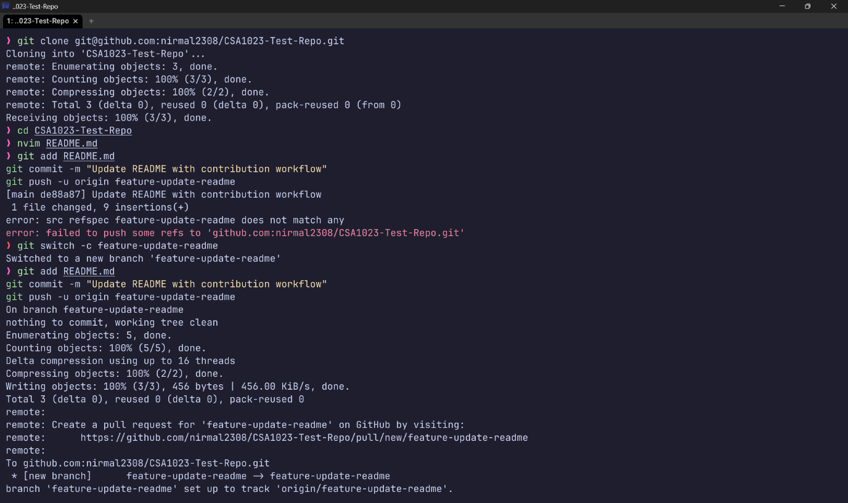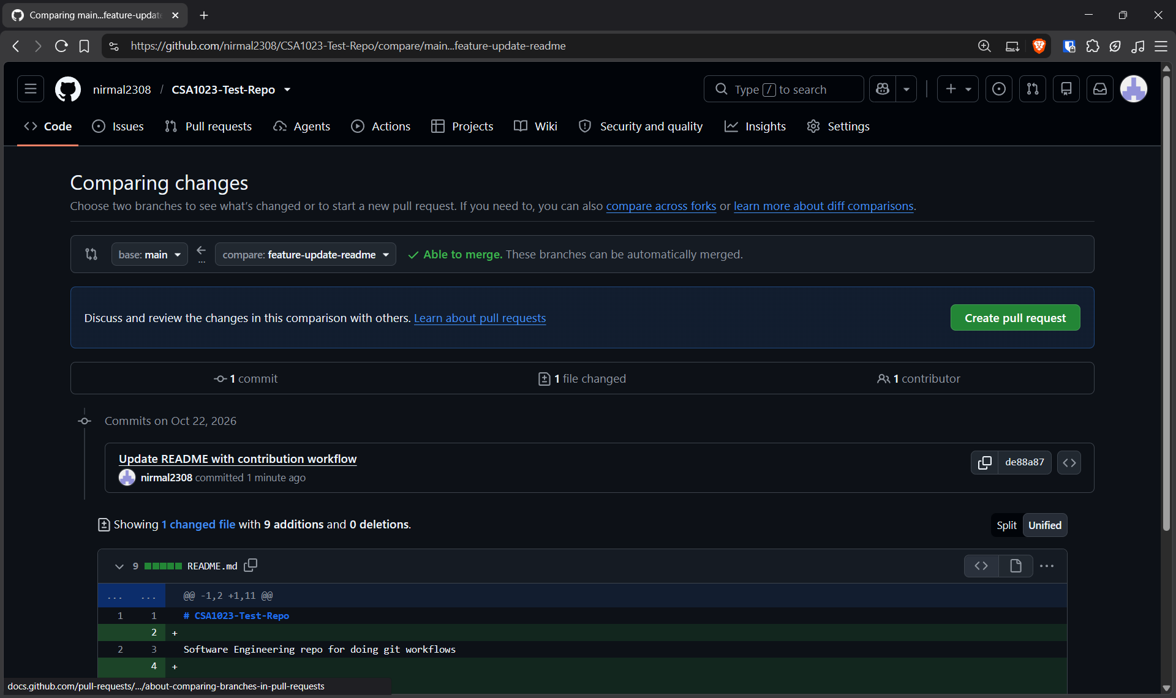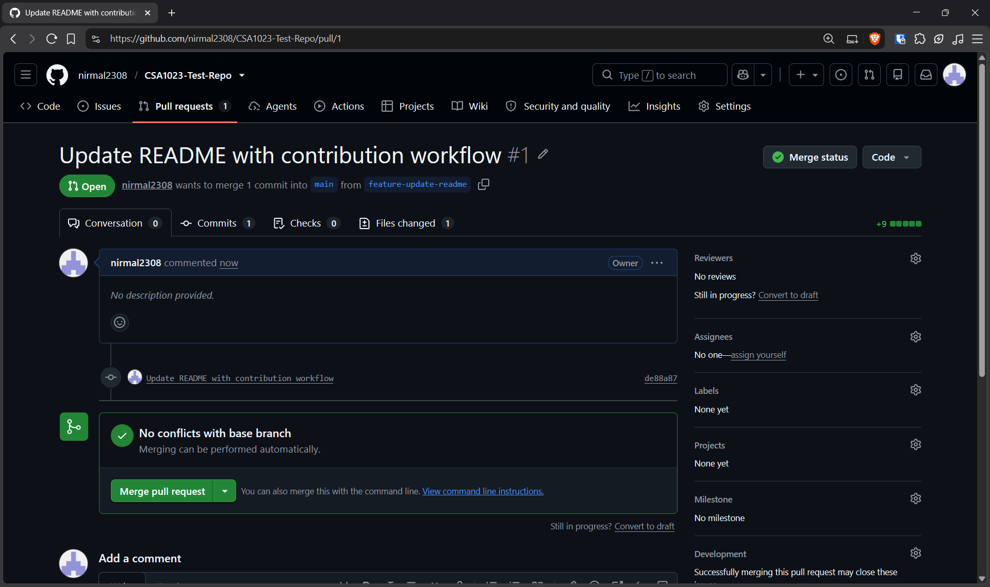

Result: Thus, The Pull request created and successfully merged after review.

